**Harry, Meghan Accused Britain’s Royal Family of Bad Treatment**

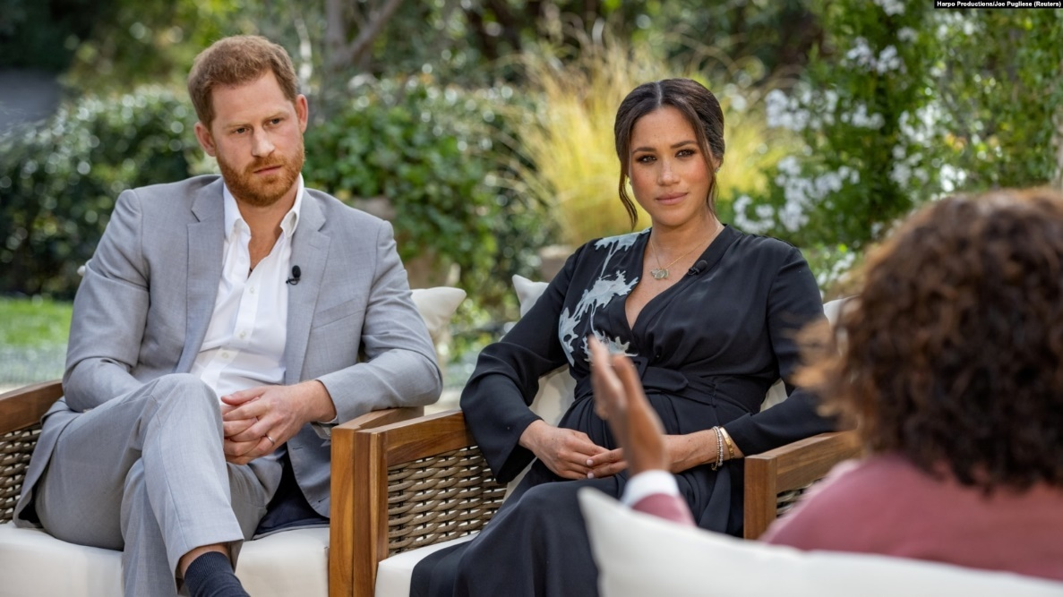

Meghan, the wife of Britain’s Prince Harry, and her husband spoke to American Oprah Winfrey Sunday on American television.

Meghan accused Britain’s royal family of being worried about her son’s skin color, and of causing her to have thoughts of harming herself. Meghan also said on the program that her requests for medical attention were refused.

Their discussion will be replayed in Britain on Monday.

Meghan’s mother is Black and her father is white. She said her son Archie had been denied the **title**of prince because of concerns about his race.

“That was **relayed** to me from Harry,” she said, saying that her concerns had been expressed to her husband and not to her. Neither Meghan nor Harry would say who had made the statements.

Harry said his family had cut them off financially. He also said his father Prince Charles refused to accept his telephone calls at one point.

Nearly three years since her 2018 wedding in Windsor Castle, Meghan described some members of the royal household as **cruel**, lying and racist.

She also accused Kate, wife of Harry’s brother Prince William, of making her cry before her wedding. She said she had thoughts of suicide.

“I just didn’t want to be alive any more. And that was very clear and real and frightening,” Meghan said.

Meghan was known as Meghan Markle before marrying Prince Harry. She became famous after appearing in the American TV program “Suits.”

The British royal family has not yet commented about the accusations.

**‘Really let Down”**

Harry and Meghan, known as the Duke and Duchess of Sussex, announced in January 2020 that they would leave their royal duties. The move caused a crisis for the royal family.

Last month, Buckingham Palace confirmed the split would be permanent.

Harry is 36 years old. He said he and his wife had left royal duties because he was worried that Meghan might be driven to her death by Britain’s **tabloid**newspapers. His mother Diana died in a 1997 car crash as she was being chased by photographers.

“What I was seeing was history repeating itself, but definitely far more dangerous — because then you add race in, and you add social media in,” Harry said.

“I had three **conversations** with my grandmother, and two conversations with my father before he stopped taking my calls. And then he said, can you put this all in writing?” Harry said.

He felt “really let down” by his father.

Both Meghan and Harry said they did receive support from the queen.

**Additional accusations**

Meghan has been accused of **bullying** employees of the palace, a charge that appeared in British tabloids. Buckingham Palace said it would investigate the accusations.

Meghan told Winfrey that palace employees failed to protect her and lied to protect others.

“It was only once we were married and everything started to really worsen that I came to understand that not only was I not being protected but that they were willing to lie to protect other members of the family,” Meghan said.

Meghan said she and Harry were not paid to talk to Winfrey.

The two also said that Meghan, who is pregnant with their second child, was expecting a girl.

The royal family has other problems. The largest is Prince Andrew’s friendship with Jeffrey Epstein, who was found guilty of sex crimes and later died in prison. That led Andrew, Harry’s uncle, to be removed from royal duties.

I’m Susan Shand.

Source: <https://learningenglish.voanews.com/a/harry-meghan-accused-britain-s-royal-family-of-bad-treatment/5806299.h>

**EXERCISES**

1. **Em linhas gerais, comente sobre o assunto principal abordado no texto.**

The text deals with what appears to be a journalistic text that talks about the problems of the royal family in Great Britain, mainly those related to Prince Harry wife, Meghan, problems caused by the race of Meghan and their son, Archie.

1. **Explique a relação entre a linguagem verbal (escrita) e a linguagem não verbal (imagem).**

Relating the image to the text we see that only with the title it shows when Meghan and her husband Harry declare the accusations of the royal family in an interview.

1. **São exemplos de palavras cognatas do texto.**
2. Also – described- acussed
3. confirmed – father – worried
4. Crimes – conversations – problems
5. Protect – told- started
6. **Coloque (V) para as informações verdadeiras e (F) para as informações falsas.**
7. (F) Meghan nunca foi acusada de intimidação de empregados do palácio.
8. (V) Tanto Meghan como Harry disseram ter recebido apoio da rainha.
9. (F) Ela tornou-se famosa antes de aparecer no programa televisivo americano "Suits".
10. (V) Meghan disse a Winfrey que os empregados do palácio não a protegeram e mentiram para proteger os outros.
11. (V) Ela também acusou Kate de a fazer chorar antes do seu casamento.
12. (F) Os dois disseram também que Meghan, que está grávida do seu segundo filho, estava à espera de um menino.
13. **Indique as linhas em que se encontram as seguintes informações:**
14. Meghan disse também, no programa, que os seus pedidos de atenção médica foram recusados.

Line: 4-5.

1. Quase três anos após o seu casamento em 2018 no Castelo de Windsor, Meghan descreveu alguns membros da família real como cruéis, mentirosos e racistas.

Line:14-15.

1. Meghan disse que ela e Harry não foram pagos para falar com Winfrey.

Line:46.

1. A família real britânica ainda não se pronunciou sobre as acusações.

Line:22.